Enterprise Telecom Fiber Churn Intelligence
Technical Design Document

Version 1.1.0
Date: June 17, 2026
Classification: Internal — POC

Table of Contents
1. Executive Summary
2. System Overview
3. Architecture & Component Diagram
4. Data Pipeline Design
5. Dashboard
6. Machine Learning Model Design
7. Appendices

1. Executive Summary
The Enterprise Telecom Fiber Churn Intelligence system is a proof-of-concept (POC) platform designed to predict customer churn for fiber broadband subscribers. Built on a three-tier microservices architecture, the system comprises a FastAPI-based ML inference service, a Spring Boot integration layer, and a React-based interactive dashboard served via Express.
The platform ingests synthetic customer data (8,000 records), trains a Random Forest classifier achieving an F1 score of 0.889 and combined score of 0.800, and exposes churn predictions through a unified REST API. A configurable threshold-tuning mechanism enables three campaign profiles — Retention, Balanced, and Conservative — allowing business teams to align churn interventions with operational cost tolerance.

2. System Overview

2.1 Purpose
Provide telecom operations teams with a real-time churn risk scoring engine that ingests customer attributes and returns a churn probability, risk level (HIGH/MEDIUM/LOW), and campaign-appropriate threshold decision. The system is designed for extensibility to production-scale workloads.

2.2 Key Capabilities
- Synthetic customer data generation (10,000 records) with realistic churn drivers
- Machine learning model training pipeline with automated hyperparameter tuning
- Threshold tuning for three business campaign profiles
- RESTful API for single-customer churn prediction
- Feature importance analysis for model interpretability
- Interactive dashboard with dataset overview, model performance, and live prediction feed

2.3 Technology Stack
Layer | Technology | Version / Config
ML Runtime | Python 3.14 | scikit-learn, pandas, numpy, joblib
ML Inference API | FastAPI | v1.1.0, uvicorn
Integration Layer | Spring Boot | Java microservice on port 3333
Frontend UI | React 18 + Vite | Express server on port 4000
Data Format | CSV | fiber_customers_realistic.csv, 8,000 rows
Model Persistence | Joblib | churn_model.pkl, model_columns.pkl
Configuration | JSON | threshold_tuning.json, training_summary.json

3. Architecture & Component Diagram
The system follows a three-tier architecture with clear separation of concerns:

3.1 Tier 1: Data & Model Layer (Python)
The data generation script (generate_dataset.py) produces a synthetic CSV dataset with 15 customer attributes plus a churn label. The training pipeline (train_model.py) performs feature engineering, trains Random Forest and Extra Trees classifiers via randomized search with 3-fold stratified cross-validation, selects the best model by combined F1/ROC-AUC score, and serialises the model and feature columns to pickle files.

3.2 Tier 2: API & Integration Layer
Two services comprise this tier:
• FastAPI : Serves the trained model via /predict, /feature-importance, and /threshold-tuning endpoints.
• Spring Boot: Acts as an enterprise integration layer, proxying predictions, providing batch churn data via /api/churn/getchurndata, and translating customer JSON for the ML service.

3.3 Tier 3: Presentation Layer (UI)
An Express serves a React SPA built with Vite. The dashboard fetches customer data from the local CSV, model metrics from FastAPI, and live prediction feeds from Spring Boot. A tabbed interface organises Overview, Model Performance, and Insights & Predictions views.

3.4 Request Flow

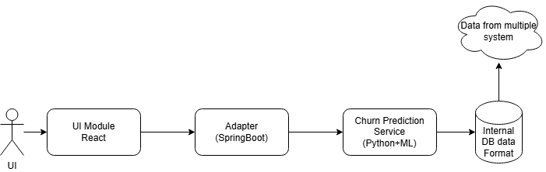

4. Data Pipeline Design

4.1 Data Generation
Generate 8,000 synthetic customer records with realistic churn drivers. Feature distributions approximate real-world telecom patterns:
Attribute | Type | Distribution
Plan | Categorical | Basic (25%), Plus (25%), Premium (25%), Ultra (25%)
monthlyPrice | Continuous | 699, 999, 1499, 2499 (tied to plan)
tenureMonths | Integer | Uniform 1–60
Outages | Integer | Random 0–8
complaints | Integer | Random 0–7
supportCalls | Integer | Random 0–8
latePayments | Integer | Random 0–5
competitorAvailable | Binary | 50% each
monthlyContract | Binary | 50% each
speedMbps | Integer | 100/200/500/1000 (tied to plan)
avgMonthlyUsageGb | Integer | N(180, 70), clipped ≥20
recentPlanChange | Binary | 18% true
contractRenewalDue | Binary | 25% true
Region | Categorical | North, South, East, West (uniform)
Churn | Binary | ~30% positive rate via logistic churn scoring

4.2 Churn Scoring Formula
Each record receives a churn probability derived from a logistic function of weighted feature contributions:
churn_score = 0.12×outages + 0.10×complaints + 0.08×supportCalls + 0.14×latePayments + 0.15×competitor + 0.10×(tenure<6) + 0.08×(price>1200) + 0.12×recentPlanChange + 0.10×contractRenewalDue + 0.10×(usage<80) + 0.03×(monthlyContract and tenure<12) + N(0,0.15)
churn_probability = 1 / (1 + e^(-churn_score))

4.3 Training Pipeline
- Feature engineering: service_stress (outages+complaints+supportCalls), billing_risk (latePayments×price/100), price_per_mbps (price/speed), usage_drop (usage<80), tenure_bucket (new/short/mid/long)
- One-hot encoding of plan, region, and tenure_bucket → 28 features total
- Train/test split: 80/20 stratified by churn label
- RandomizedSearchCV with 2 iterations, 3-fold stratified CV, F1 scoring
- Model candidates: RandomForestClassifier, ExtraTreesClassifier
- Selection metric: 0.7 × F1 + 0.3 × ROC-AUC (combined score)
- Winner: RandomForest (n_estimators=250, max_depth=12, min_samples_leaf=2, class_weight=balanced_subsample)
- Threshold tuning across 17 thresholds from 0.10 to 0.90

5. Dashboard View

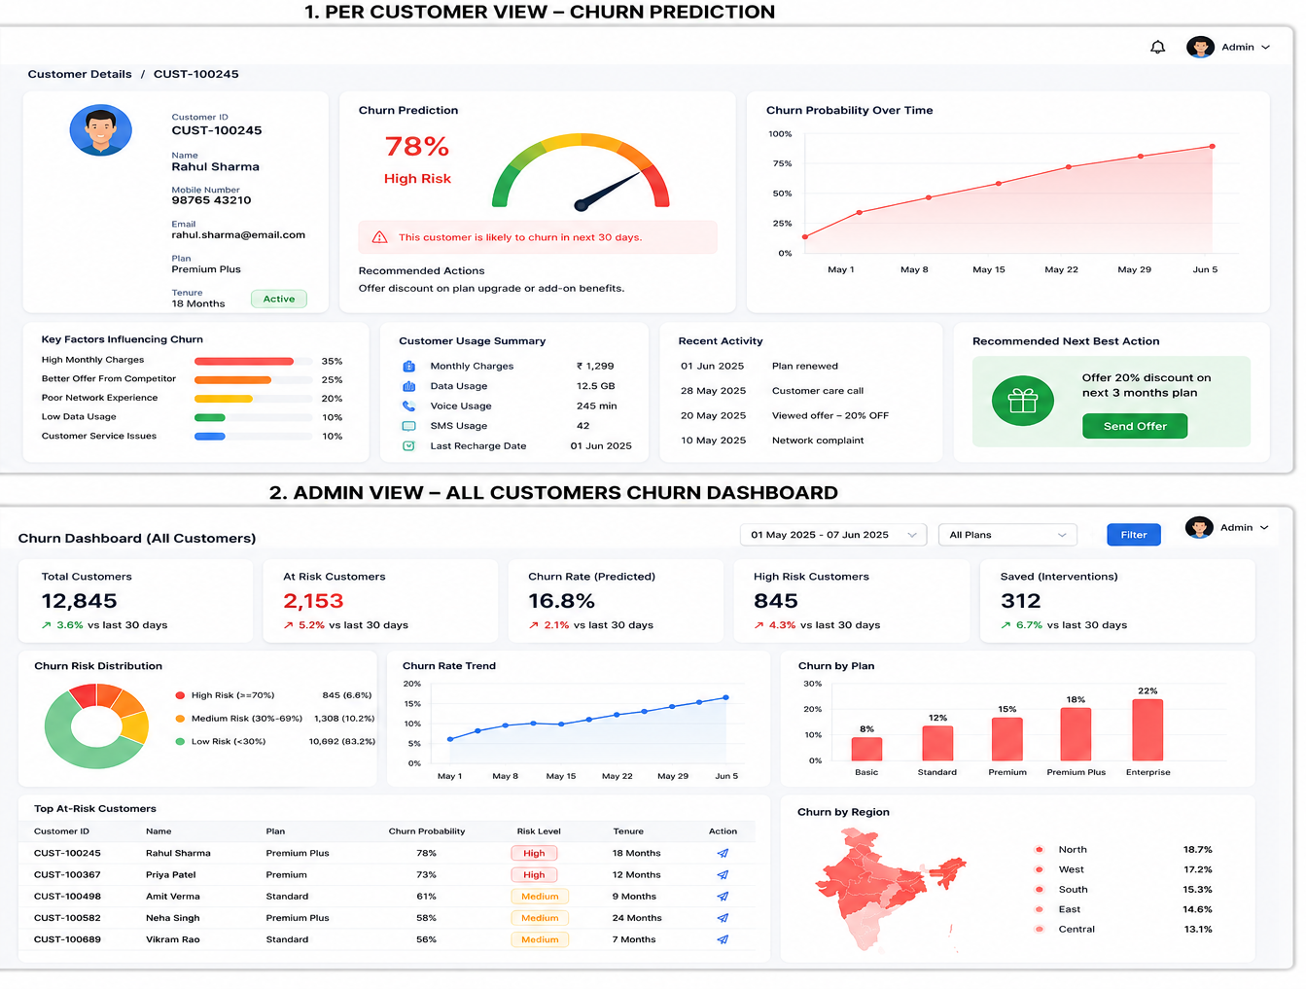

6. Machine Learning Model Design

6.1 Feature Importance (Top 8)
Feature | Importance Score
monthlyPrice | High
tenureMonths | High
latePayments | High
Outages | Medium-High
Complaints | Medium-High
service_stress | Medium-High
competitorAvailable | Medium
monthlyContract | Medium

7. Appendices

A. Data Dictionary
Complete attribute reference for the customer dataset and prediction request schema.

B. Glossary
Term | Definition
Churn | Customer cancellation of fiber subscription
Retention Campaign | Proactive outreach to at-risk customers before they churn
Precision | TP / (TP + FP) — accuracy of positive predictions
Recall | TP / (TP + FN) — ability to find all positive instances
F1 Score | Harmonic mean of precision and recall
ROC-AUC | Area under the receiver operating characteristic curve
Random Forest | Ensemble of decision trees trained on bootstrapped samples
StratifiedKFold | Cross-validation that preserves class proportions in each fold

